|  |
| --- |
| Configure New Merchant  Guideline |
|  |
| Description: hp_logo |
| Version:1.0  Effective Date: 07-2012 |  |

# Revision History

|  |  |  |  |
| --- | --- | --- | --- |
| **Version** | **Date** | **Author** | **Comment** |
| 1.0 | 7/23/2012 | Gong, Wei | Initial Draft |
|  |  |  |  |
|  |  |  |  |

**Key Contributors:** Shui, Tian-Yi; Zhao, Ying; Lu, Li-Jun; Feng, Jie.

# Overview

When PGS needs to configure new merchant, corresponding component in PGS platform need to add some information to configuration file and change some settings. This guideline focuses on how to add information and change corresponding settings for the new merchant.

# Assumption

1. The component needs to change corresponding configuration only when the new merchant will use this component.
2. This guideline is for PGS DEV team internal use only.

# Component Configuration

## PGS Admin Site

1. Domain(Amy) create corresponding site and store on PGS Admin Site

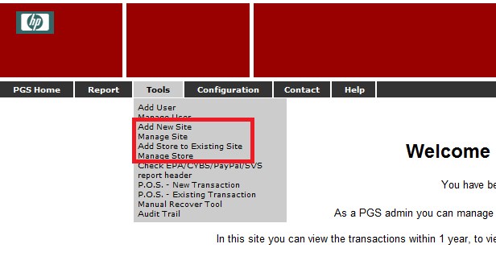

1. Find corresponding “MerchantID”, “Bank Name” information from PGS Admin Site, and confirm it with Domain.
2. Find “Bank Name” from Manage Store page

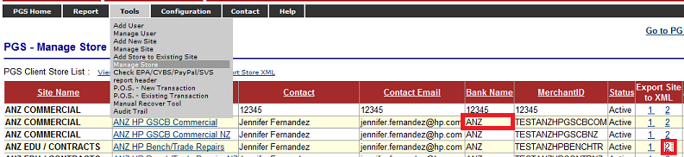

1. Click the “2” link in “Export Site to XML” column, and find “MerchantID” from popup XML.

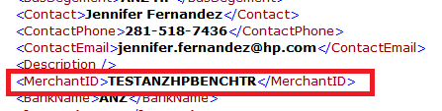

1. Get “Banking ID” information from Domain(Amy).

Note: All of above information have to be confirmed with Domain

1. Insert “CybersouceMID(MerchantID)”, “Processor(based on Bank Name)”, and “Banking ID” into tb\_PGS\_HPAccounts table in PGS\_Report database.

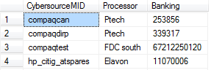

## PHC

1. Get storefront information for the new merchant from Domain.
2. Get “StoreID”, “CurrencyCode” for the new merchant from PGS Admin Site. If it doesn’t exist in PGS Admin Site, confirm it with Domain.
3. Go to Manage Store page, and select corresponding store for the new merchant

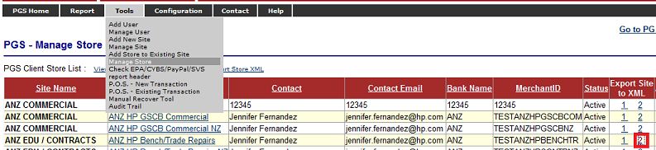

1. Click the “2” link in “Export Site to XML” column, and find corresponding “MerchantID”, “StoreID” and “CurrencyCode” in popup XML.

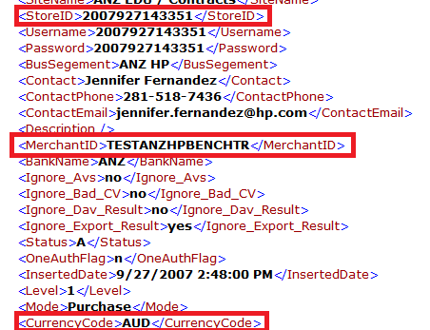

1. Get “CardType”, “ReturnUrl(Token Listener)” information for the new merchant from Domain.
2. Get Auth Type(0 $ auth, 1$ auth or bypass 0 $ auth) information from Domain.
3. Generate “MerchantName” for the new merchant, and confirm it with Domain.

Note: All of above information have to be confirmed with Domain

1. Configure all of above information to the **PaymentReceiver.xml** file.

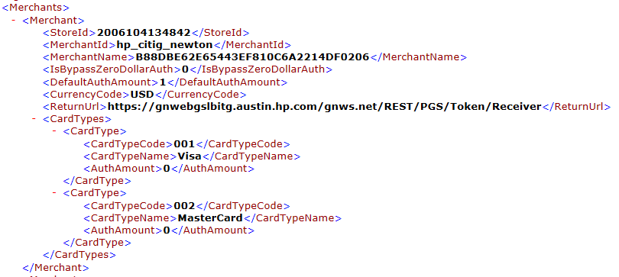

## PGS Green Screen

1. Get “MerchantID”, “MerchantName” and “CardType” information.

Note: This information should be the same as PHC configuration.

1. Add corresponding “MerchantID”, “MerchantName”, “CardType” information to **Merchants.xml** file.

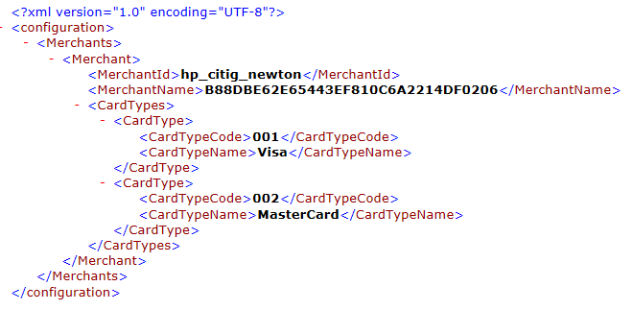

## PGS Web Service

1. Get “MerchantID”, “StoreID” and “SiteID” from Domain.



**PGS 2.2:**

1. Get corresponding storefront and credit card processor information from domain

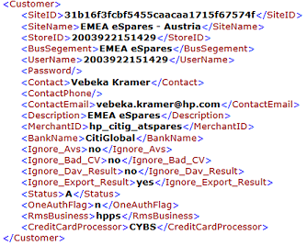

1. Confirm PayPal information with Domain.

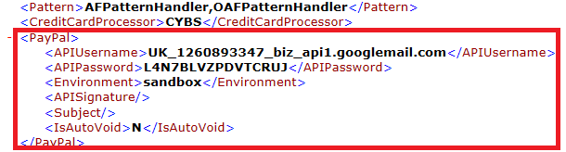

1. Confirm “RMS” and “VCP” information with Domain if the new merchant needs to handle corresponding processes.

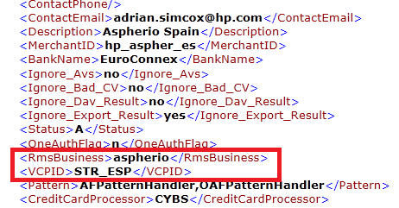

1. Configure all of above information to **“PGS\_Cust.xml”** file

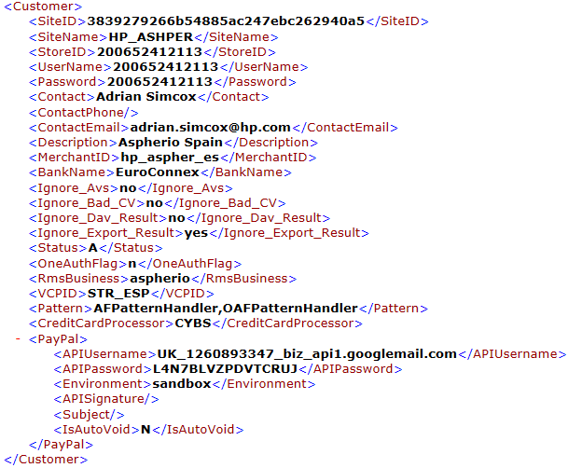

**PGS 3.0**

1. Confirm “Pattern”, “SaveCVN” and “Satus” information with Domain.

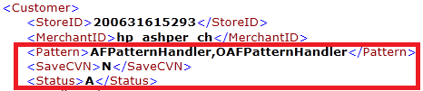

1. Confirm corresponding payment processor information with Domain
2. CYBS (if needed)

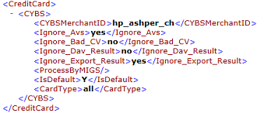

1. ANZ (if needed)

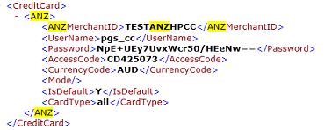

1. Gift Card (SVS) (if needed)

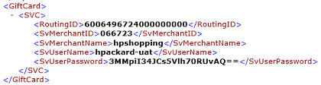

1. PayPal (if needed)

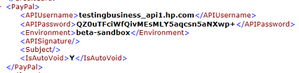

1. Confirm “RMS” and “VCP” information with Domain if the new merchant needs to handle corresponding scenario.

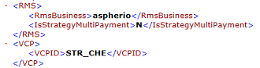

1. Configure all of above information to **“PGS30\_Cust.xml”** file.

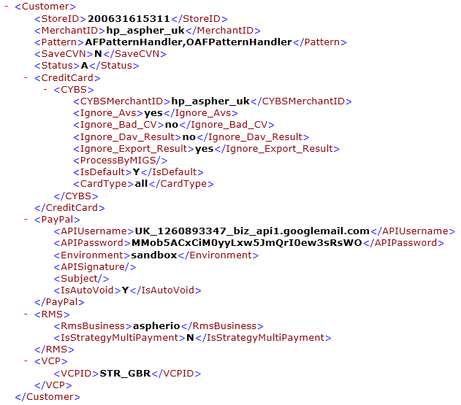

## PGS Recon

1. CYBS settlement report download configuration.
2. Confirm with Domain(Amy) if PGS need to download CYBS settlement report for this new merchant, and get corresponding “MerchantID” for the new merchant from Domain(Amy).
3. If PGS need to download CYBS settlement report for this new merchant, configure “MerchantID”, “MerchantName” and “PWD” of this new merchant in the **CCCYBS.RevRecon.xml** file in Recon platform.

Note: All of the storefront should share the same “MerchantName” and “PWD” for downloading CYBS settlement report.

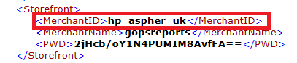

1. PayPal settlement report download configuration.
2. Confirm with Domain(Amy) if PGS need to download PayPal settlement report for this new merchant, and get corresponding “MerchantName”, “MerchantID” and “IsSendRecon”(Need to send iDoc for this merchant?) information for the new merchant from Domain.
3. Confirm the PayPal SFTP information with Domain for this new merchant.

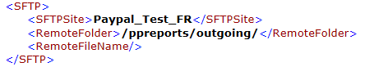

1. Configure all of above information to **“Paypal.RevRecon.xml”** file.

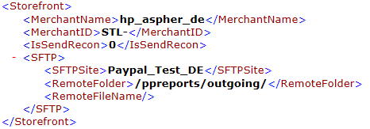

1. Confirm the “Coreftp” configuration with Domain.

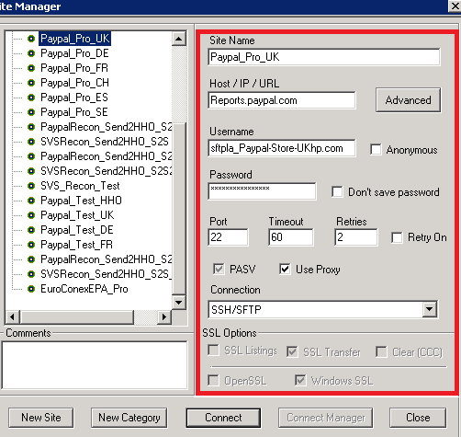

1. Add all of “Coreftp” configuration to **“CoreFTP.config”** file**.**
2. iDoc configuration.
3. Confirm with Domain(Amy) if PGS need to send iDoc for this new merchant.
4. If PGS need to send corresponding iDoc for this new merchant, go to Manage IDoc Config page in PGS Admin Site.

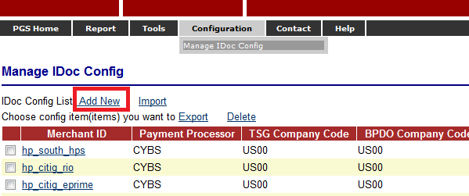

1. Click the “Add New” link, and then set corresponding configure values according to information provided by Domain(Amy).

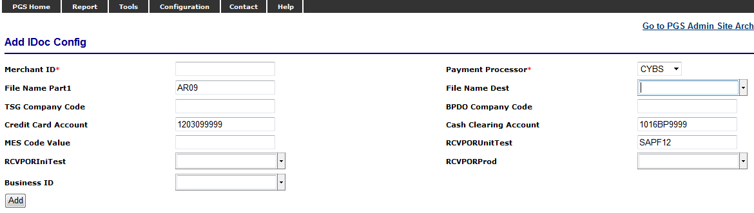

1. Add “MerchantID” to **CCIDoc.SendRecon.xml** file.

****

## RMS

1. Get corresponding business information for the new merchant from Domain(Amy).
2. Login into RMS, scroll down to the bottom and click the “Add Business” button.

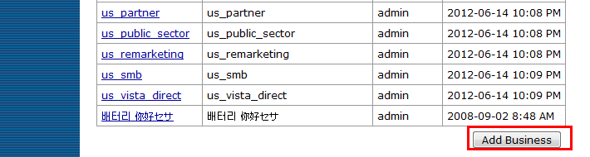

1. In the following page type name and description then click “Add Business” button.

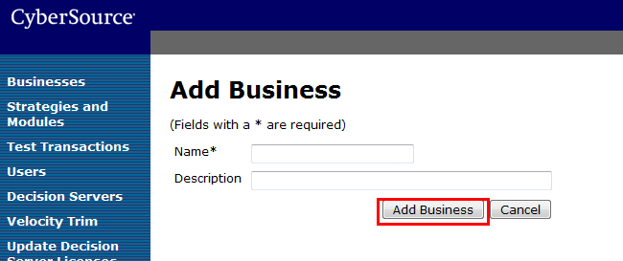

## FQM

1. Get corresponding business information for the new merchant from Domain (Amy).
2. In the FQM login page, select the “Add a New Business” business. Use your FQM account to login.

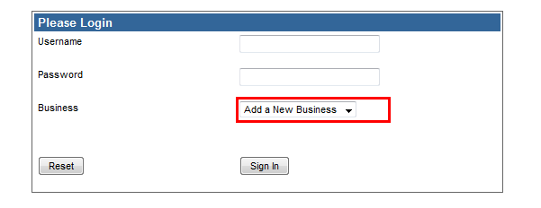

1. In the following page, type your business info and click the “Submit Query” button.

Note: Business/name/GC is required , stoteID is optional.

